ASIAN PORCHETTA TOSCANA
2750 Colorado Blvd., Unit # 2, Los Angeles, CA 90041-1063

www.AsianPorchetta.com • www.PorchettaToscana.com
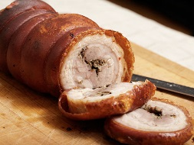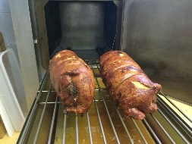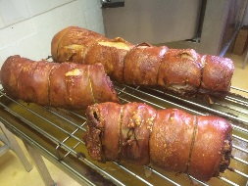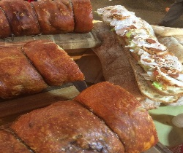 |  | 1 - If frozen, thaw in fridge overnight.  2 - Preheat oven to 400 degrees F.  3 - Remove the netting.  4 - Place in a roasting pan or flat pan and put into the oven and warm uncovered for 40 minutes or until internal temperature reads 140 degrees F.  5 - Remove from the oven and let rest 5 minutes. It’s ready to eat!
THE KEY TO CRACKLING
• NEVER cover the skin during cooking (it will cause the roast to steam).
• Rotate the roast every ten minutes to encourage even heating and crisping in the oven,
especially if you don’t have a convection oven.
• Use a roasting rack – placing the roast above the bottom of the roasting pan ensures more
dry air cooking, which means more crackling.

SERVING IDEAS
• Keep it simple – no need to add salt or additional seasonings.
• Roast potatoes and/or apples along with the Asian Porchetta Toscana for a built-in side dish.
• The flavors are rich – slice thinly (no more than 1/2-inch thick) and be sure to include the
crackling skin.
• Asian Porchetta Toscan can be enjoyed warm or cold. Serve as an entrée or create the best
sandwich. All you need is two pieces of bread and a couple of slices of Asian Porchetta
Toscana.

